THE UNIVERSITY OF DODOMA

COLLEGE OF INFORMATICS AND VIRTUAL EDUCATION

DEPARTMENT OF COMPUTER SCIENCE AND ENGINEERING

FINAL YEAR PROJECT REPORT
BSc Computer Networks and Information Security Engineering (CNISE)

PROJECT TITLE: SECURING TRANSMISSION OF BIOMETRIC DATA FROM SENSOR TO AUTHENTICATION ENGINE.

STUDENT’S PARTICULARS: GROUP 10
S/N | REGISTRATION NUMBER | STUDENT’S NAMES
1. | T21-03-02345 | ANGELINA A. KILINDO
2. | T21-03-15705 | BARAKATI ABDI HUSSEIN
3. | T21-03-03127 | ESTOMINIH EPHREM SANAYA
4. | T/UDOM/2020/05258 | ELISHA M MAHENDA

SUPERVISOR NAME: MS NEEMA COORDINATOR NAME:
Signature: ............................… Signature: ............................…

SEMISTER ONE
TABLE OF CONTENTS
LIST OF TABLES i
LIST OF FIGURES ii
CHAPTER 1: INTRODUCTION 1
1.1. Background 1
1.2. Problem Statement 1
1.3. Solution 1
1.4. Main Objective 1
1.5. Specific Objectives 2
1.6. Scope 2
CHAPTER 2: LITERATURE REVIEW 3
2.1 Challenges in Biometric Authentication Security 3
CHAPTER 3: METHODOLOGY 4
3.1. Introduction to Development Methodology 4
CHAPTER 4: PROGRESS MADE 8
4.3 Non-Functional Requirements 10
Actors and Their Responsibilities 13
4.5.3 Data Flow Diagram (DFD) 14
DFD Level 0 (Context Diagram) 14
DFD Level 1 (Detailed Data Flow) 15
Key Entities and Their Attributes: 16
Relationships Between Entities: 17
CHAPTER 5: PROJECT TIMELINE AND BUDGET 18
5.1 Project Timeline 18
5.2 Project Budget 19
CONCLUSION 20

LIST OF TABLES
Table 1 : Project Timeline 19
Table 2 : The Project Budget 19

LIST OF FIGURES
Figure 1 : Agile Methodology 4
Figure 2 : System Design Architecture 7
Figure 3 : Attacks on biometric systems 9
Figure 4 : Use case Diagram 13
Figure 5 : DFD Level 0 14
Figure 6 : DFD Level 1 15
Figure 7 : Entity-relationship diagram (ERD) 16

CHAPTER 1: INTRODUCTION

Background
Biometric authentication systems are widely used in industries such as IoT, smart cities, and automation to enhance security and identity verification. However, the transmission of biometric data from the sensor to the authentication engine remains a critical vulnerability. Attackers can intercept, modify or manipulate biometric transactions, leading to identity theft, unauthorized access, and security breaches. Existing security measures often lack robust protection against data interception, tampering, and replay attacks, making biometric authentication systems susceptible to exploitation.

Problem Statement
To ensure secure transmission, it is essential to implement strong encryption, integrity verification, and authentication mechanisms that protect biometric data against unauthorized access and modification. A more resilient and secure approach is needed to guarantee the authenticity, confidentiality, and integrity of biometric data as it travels from the sensor to the authentication engine.

Solution
This project aims to ensure the secure transmission of biometric data from the sensor to the authentication engine by implementing robust security measures. These include encryption to protect biometric data from interception, authentication mechanisms to verify the legitimacy of data sources, and integrity checks to prevent unauthorized modifications. By integrating these security techniques, the system will safeguard biometric transactions, ensuring they remain confidential, authentic, and tamper-proof throughout transmission.

Main Objective
Secure biometric data transmission with strong authentication, encryption, and integrity measures to prevent unauthorized access, interception, and tampering.

Specific Objectives
- To identify security risks in sensor-to-authentication engine in biometric data transmission and determine the most effective protection mechanisms.
- To design and implement an encryption mechanism.
- To develop an authentication and integrity verification framework that prevents unauthorized access and detects data tampering.

Scope
This project, titled "Secure Transmission of Biometric Data from Sensor to Authentication Engine", focuses on enhancing the security of biometric data as it travels from the sensor to the authentication engine in identity verification systems. The scope of the project is specifically defined within the following areas:
- Identification of Security Risks: The project will analyze potential vulnerabilities in the communication channels between the biometric sensor and the authentication engine, identifying possible threats such as data interception, unauthorized access, and tampering.
- Design and Implementation of Encryption Mechanisms: The project will focus on developing and integrating encryption algorithms to ensure the confidentiality of biometric data during transmission, safeguarding it from unauthorized interception.
- Authentication and Integrity Protection: The project will include the development of an authentication framework to verify the legitimacy of the data sources and ensure the integrity of the transmitted data. This will prevent unauthorized modifications and guarantee the authenticity of the biometric data.
- Security and Performance Evaluation: The project will assess the effectiveness of the implemented security measures through rigorous penetration testing and performance analysis. This will ensure the solution's robustness in real-world scenarios and its ability to maintain both high security and system efficiency.
- Exclusion of Post-Transmission Data Handling: This project will not address the storage, processing, or post-transmission handling of biometric data, focusing solely on securing the transmission process from sensor to authentication engine.

CHAPTER 2: LITERATURE REVIEW
Biometric authentication is widely used to verify identity, but sending biometric data from sensors to processing systems can be risky. Hackers can steal or change this data if it is not well protected. This chapter looks at past research on how to secure biometric transactions using encryption, authentication, and other security methods.

2.1 Challenges in Biometric Authentication Security
Wang et al. (2023) review the most common security problems in biometric systems, such as spoofing attacks, stolen biometric data, and hacking attempts. They suggest that a combination of strong encryption, security checks, and continuous authentication is the best way to prevent these risks.

From the research reviewed, it is clear that biometric transactions must be secured using encryption, authentication, and integrity checks. Many researchers have explored different techniques like AI-based encryption, reversible data hiding, and multi-biometric authentication. Our project builds on these ideas by focusing on securing biometric transactions from sensors to processing engines using encryption and data protection methods.

CHAPTER 3: METHODOLOGY

3.1. Introduction to Development Methodology
For the development of Secure Transmission of Biometric Data from Sensor to Authentication Engine project, the Agile methodology has been chosen to guide the project through an iterative, flexible, and collaborative process.
Secure Transmission of Biometric Data from Sensor to Authentication Engine project is best suited with agile software development methodology because;
- Flexibility and Adaptability: Agile allows the development team to be highly flexible, making adjustments as needed and responding to new insights or challenges related to security risks, encryption protocols, and other aspects of the project as the biometric systems and security requirements are complex and may evolve during the course of the project.
- Continuous Improvement and Feedback: The iterative nature of Agile provides continuous testing and feedback loops.
- Faster Time to Market: Agile methodology focuses on delivering working increments early and continuously.
- Collaboration and Transparency: Agile emphasizes collaboration among stakeholders, including developers, security experts, and project managers.
- Risk Management: The regular checkpoints and reviews inherent in the Agile methodology help identify risks early, especially in security-critical systems.
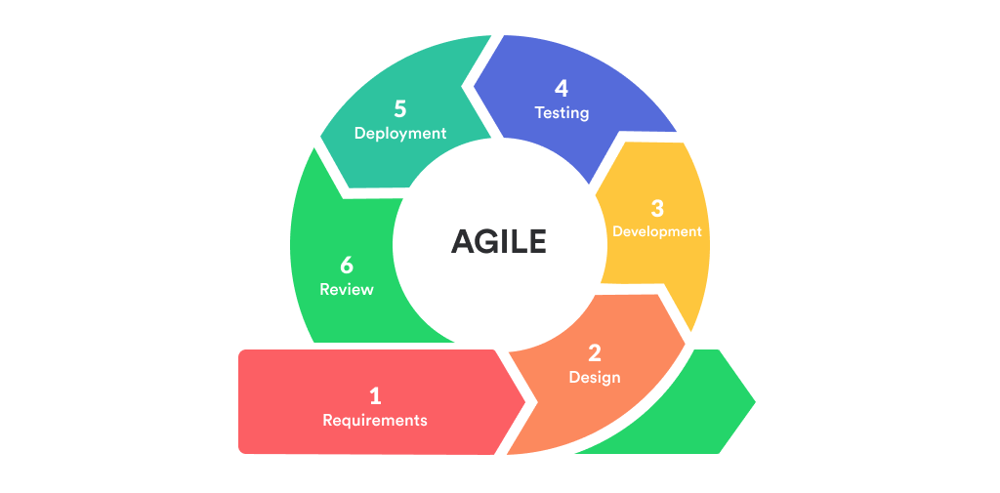
Figure 1: Agile Methodology

3.2. Objectives methods
The development of Secure Transmission of Biometric Data from Sensor to Authentication Engine will follow an Agile methodology, emphasizing iterative progress, flexibility, and continuous improvement throughout the project lifecycle. Each component of the system will undergo the same iterative phases, ensuring that every part of the system is developed, tested, and integrated with the others in manageable increments.

The Planning Phase is the initial stage where the overall project scope is established. The team will gather detailed requirements from stakeholders, defining the functionality, security specifications, and design needs. This phase also includes the creation of user stories and a prioritized project backlog to guide future development efforts.

During the Design Phase, the system's architecture will be developed, ensuring that all components of the secure transmission system work seamlessly together. The focus will be on designing encryption mechanisms, authentication methods, and data integrity checks, ensuring the system's security. Prototypes will be built to test critical features, such as encryption algorithms, and validate the feasibility of the design before actual development begins.

On Development Phase is where the codes are written by a development team to produce the functionality of a system. The bulk of the work occurs, and it will be broken into several sprints. In each sprint, specific tasks, such as building encryption, authentication, and integrity components, will be completed. The development team will focus on writing code for each component, performing unit tests, and frequently integrating new code to ensure that it aligns with the project's overall goals. Agile's iterative nature allows for regular refinement of the system, addressing any emerging issues as they arise.

In the Integration Phase, the individual components developed during the previous sprints will be brought together. This phase ensures that the system's various parts, including encryption, authentication, and data integrity checks, work together as a cohesive whole. Integration testing will be performed to identify potential issues, and any problems will be addressed promptly. The goal is to ensure that data flows securely from the sensor to the authentication engine without any data leaks or vulnerabilities.

The Testing Phase is dedicated to rigorous testing of the system to ensure that it meets all functional and security requirements. Penetration testing, performance testing, and user acceptance testing (UAT) will be performed to identify vulnerabilities and ensure the system performs efficiently under load. This phase ensures that the biometric data transmission is secure, reliable, and user-friendly before being deployed.
Once the system passes testing, it moves to the Deployment Phase. Here, the system will be deployed to the production environment, ensuring that it is stable and performs as expected. Continuous monitoring tools will be implemented to track system performance and detect any potential security threats in real time. Feedback from end users and stakeholders will also be gathered to assess the system's effectiveness and usability.

Finally, the Maintenance Phase ensures that the system continues to operate securely and efficiently after deployment. Regular updates, bug fixes, and security patches will be applied as necessary, based on user feedback and ongoing monitoring. The team will remain proactive in addressing any issues that arise, ensuring that the system remains secure and performs optimally over time.

3.3. Architectural/Conceptual design
The system architecture consists of a front-end interface built with frameworks like React or Vue.js, which interacts with the backend using API calls. The backend, developed in technologies like PHP or Node.js, processes business logic, communicates with biometric devices for authentication, and manages data flow between the frontend and database. The database stores user data and biometric records, ensuring secure storage and efficient retrieval of information for the system's operations.

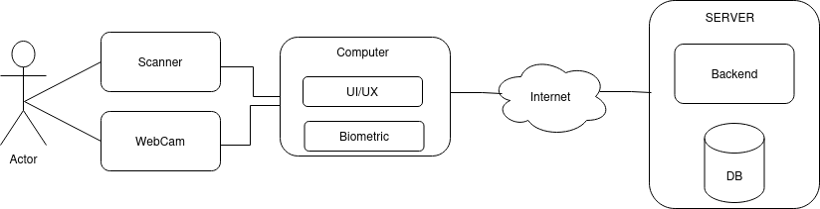
Figure 2: System Design Architecture

This diagram shows how the components are interconnected, including the communication between the front-end, backend, biometric devices, and database.

CHAPTER 4: PROGRESS MADE

4.1 Objective 01: To identify security risks in sensor-to-authentication engine in biometric data transmission and determine the most effective protection mechanisms.
The first objective of the project is to identify the security risks associated with the transmission of biometric data from the sensor to the authentication engine and to determine the most effective protection mechanisms. Biometric data, such as fingerprints, iris scans, or facial recognition patterns, is highly sensitive information and requires robust protection throughout its transmission from the sensor to the authentication engine.
This phase begins by performing a comprehensive security risk assessment, which includes identifying potential vulnerabilities in the system. These vulnerabilities may arise from various points within the transmission process, including the sensor, network channels, and the authentication engine itself. Common threats identified was data interception, man-in-the-middle attacks, data tampering, and unauthorized access to sensitive biometric data.

Once the risks are identified, the next step we determine the most effective protection mechanisms. These mechanisms include employing strong encryption algorithms to secure data during transmission, implementing robust authentication protocols to ensure only authorized users can access the system, and applying integrity checks to prevent any modifications to the biometric data during the transmission process. The goal was to ensure that biometric data is transmitted in a way that ensures confidentiality, authenticity, and integrity.

In addition, we analyzed the existing literature and security practices in similar systems which helped in identifying the most effective measures and technologies to mitigate the identified risks. Such measures is to use of advanced encryption standards (AES), secure key exchange methods, and multi-factor authentication to enhance the overall security of the biometric data transmission.
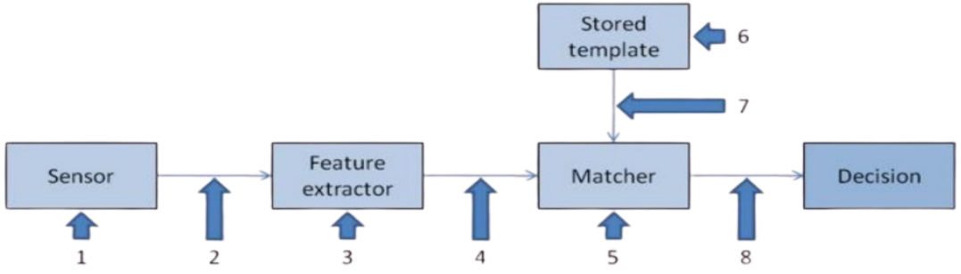
Figure 3: Attacks on biometric systems

- Attack on the Biometric Sensor:Attackers use fake biometric traits such as printed fingerprints to trick the sensor into capturing fraudulent data.
- Replay Attack: A recorded biometric signal (such as fingerprints or facial images) is replayed to the system, bypassing the biometric sensor.
- Attack on the Feature Extractor: The feature extractor is forced, e.g., by Trojan horse, to op-press single features of a biometric trait, or to produce altered values than those read by the biometric sensor.
- Tampered Feature Representation: Features extracted from the sensor input are replaced by a different (fraudulent) feature set.
- Attack on the Matcher: attacker change how the matcher works, using malware like a Trojan horse to produce incorrect results. This can allow unauthorized people to gain access or block legitimate users.(man in the middle attaker)
- Attack on Stored Biometric Templates: Templates stored in a biometric database (local, remote, or distributed) are altered, added, or deleted, compromising authentication security.
- Tampered Template Representation: Attacker replace stored biometric data with fake information to trick the system (Tamplate Injection)
- Attack on the Decision End Point: If the final matching decision is overridden by the attacker, the authentication system is disabled. This renders the biometric system useless and makes biometric data irrelevant.

4.2 Functional requirements
These requirements focus on the system's ability to process, secure, and manage biometric data during its transmission from the sensor to the authentication engine, ensuring efficiency, security, and accuracy.
- The system must capture biometric data from the sensor.
- All biometric data transmitted from the sensor must be encrypted during transmission.
- The system must authenticate users before processing their biometric data.
- The system must verify that biometric data has not been altered during transmission.
- The system must transmit biometric data in real-time from the sensor to the authentication engine.
- The system should support multi-factor authentication to enhance user verification.
- The system must detect and handle errors during data transmission securely.
- The system must restrict access to biometric data based on user roles and permissions.
- The system must maintain a log of all authentication attempts and data transmission events.
- The system must securely store biometric data and authentication records with encryption.

4.3 Non-Functional Requirements

4.3.1 Performance Requirements
The system must process biometric data efficiently, ensuring real-time authentication with minimal latency. The biometric data transmission from the sensor to the authentication engine should occur within milliseconds to provide a seamless user experience. The system must support concurrent authentication requests without degrading performance, ensuring scalability for multiple users.

4.3.2 Safety Requirements
The system must ensure safe handling of biometric data, preventing accidental data loss or corruption. In case of hardware failure, power outage, or network issues, the system should have fail-safe mechanisms such as backup storage and automatic retry mechanisms. Additionally, the system should prevent unauthorized physical access to biometric sensors and authentication devices.

4.3.3 Security Requirements
The system must implement strong encryption protocols to protect biometric data during transmission, preventing unauthorized interception or tampering. It must enforce multi-factor authentication and access controls to restrict unauthorized access. Security measures such as biometric template protection, hashing, and secure key management must be implemented to ensure data confidentiality, integrity, and authenticity.

4.3.4 External Interface Requirements (User Interfaces)
The system must provide a user-friendly interface for capturing biometric data, displaying authentication results, and managing user access. The interface should be intuitive and responsive, allowing administrators and users to interact with authentication features easily. It should also include visual and audio indicators to confirm successful or failed authentication attempts.

4.3.5 Hardware Interfaces
The system must be compatible with various biometric sensors such as fingerprint scanners, facial recognition cameras, and iris scanners. It should also support secure connections with authentication servers, encryption modules, and storage devices. The hardware should meet industry standards to ensure reliability and durability in different environmental conditions.

4.3.6 Software Interfaces
The system should integrate with existing authentication platforms, databases, and security frameworks. It must support multiple operating systems and be compatible with authentication protocols such as OAuth, OpenID Connect, and SAML. The software should also allow API access for third-party applications that require secure biometric authentication.

4.3.7 Communication Interfaces
The system must support secure communication protocols, including HTTPS, TLS, and SSL, to protect biometric data during transmission. It should ensure seamless integration with cloud services, network authentication servers, and mobile authentication applications. The communication framework should be robust enough to handle real-time data exchange without compromising security.

4.4 Objective 02: To design and implement an encryption mechanism that ensures the confidentiality of biometric data during transmission.
Structural UML diagrams provide a visual representation of how the system's components interact and function. A Use Case Diagram is used to illustrate how different users (actors) interact with the system to perform various operations related to secure transmission of biometric data from the sensor to the authentication engine.

4.5.1 Use Case Diagram for Web Application
The Use Case Diagram showcases the interactions between users and the system, focusing on the authentication process, biometric data handling, and security mechanisms. It helps in understanding system functionalities from the user's perspective.

Actors and Their Responsibilities
- User (Staff/End-User)
  - Provides biometric data (fingerprint, face, iris) for authentication.
  - Receives authentication results (approved/rejected).
  - Logs in and manages their access credentials.
- Authentication Engine (System Component)
  - Receives biometric data from the sensor.
  - Verifies biometric data against stored templates.
  - Encrypts and transmits authentication responses.
- Administrator
  - Manages user accounts and system security settings.
  - Monitors authentication logs and system activities.
  - Configures encryption and security policies.
- System Database (System Component)
  - Stores and retrieves biometric templates securely.
  - Logs authentication attempts for auditing purposes.
- Biometric Sensor (System Component)
  - Captures raw biometric data from users.
  - Transmits encrypted biometric data to the authentication engine.
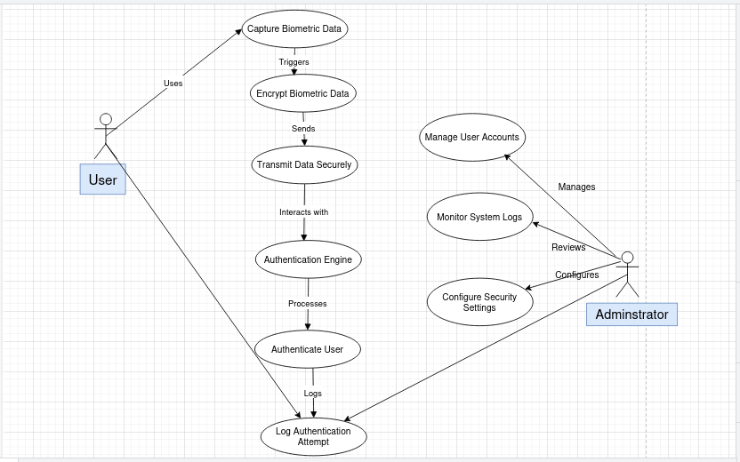

Figure 4: Use case Diagram

4.5.3 Data Flow Diagram (DFD)
A Data Flow Diagram (DFD) represents the flow of data within the system, showing how information moves from one component to another. It helps visualize system processes, data storage, and user interactions, ensuring a structured approach to secure biometric data transmission.

DFD Level 0 (Context Diagram)
At this level, the Secure Transmission of Biometric Data for Authentication Systems is represented as a single process that interacts with external entities.
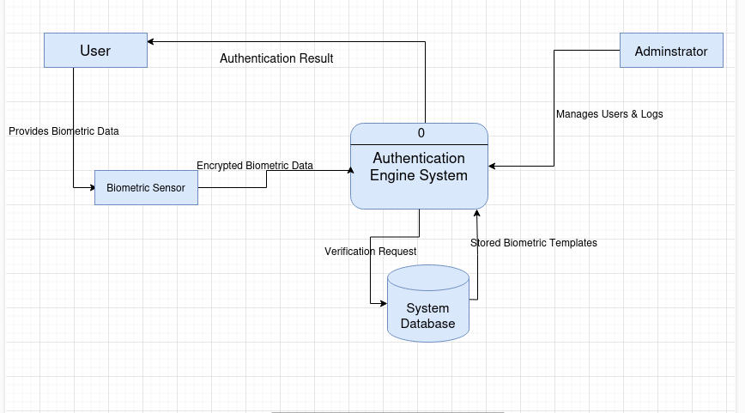
Figure 5: DFD Level 0

DFD Level 1 (Detailed Data Flow)
DFD Level 1 expands on the Context Diagram by breaking down the system into sub-processes that explain how data is handled internally.

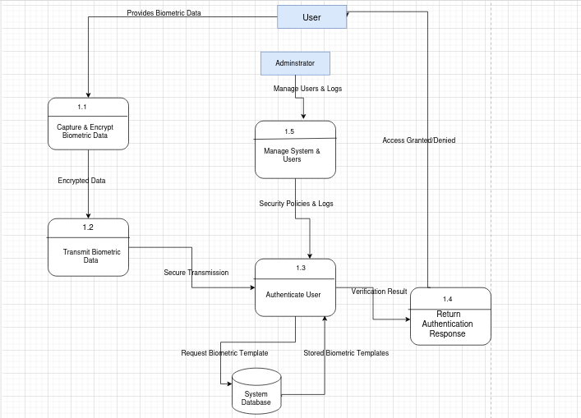
Figure 6: DFD Level 1

4.6 System design

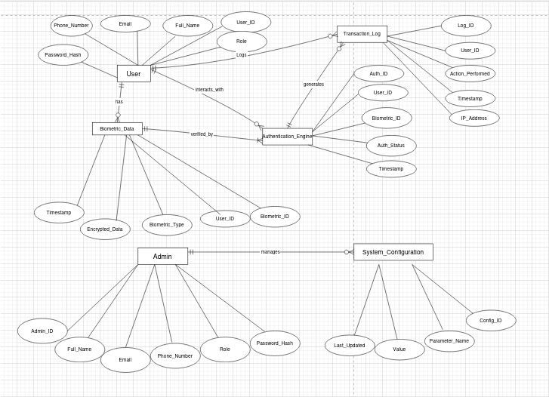

Figure 7: Entity-relationship diagram (ERD)

The Entity-Relationship (ER) Diagram represents the database structure for the Secure Transmission of Biometric Data for Authentication Systems. It defines how entities interact and the type of data stored within the system.

Key Entities and Their Attributes:
- User (Staff/End-User)
  - User_ID (Primary Key)
  - Full_Name
  - Email
  - Phone_Number
  - Role (Staff, Admin)
  - Password_Hash
- Biometric Data
  - Biometric_ID (Primary Key)
  - User_ID (Foreign Key)
  - Biometric_Type (Fingerprint, Iris, Facial Recognition)
  - Encrypted_Data
  - Timestamp

- Authentication Engine
  - Auth_ID (Primary Key)
  - User_ID (Foreign Key)
  - Biometric_ID (Foreign Key)
  - Auth_Status (Success, Failure)
  - Timestamp
- Transaction Log
  - Log_ID (Primary Key)
  - User_ID (Foreign Key)
  - Action_Performed
  - Timestamp
  - IP_Address
- Admin
  - Admin_ID (Primary Key)
  - Full_Name
  - Email
  - Phone_Number
  - Role (System Admin, Security Officer)
  - Password_Hash
- System Configuration
  - Config_ID (Primary Key)
  - Parameter_Name
  - Value
  - Last_Updated

Relationships Between Entities:
- A User can have multiple Biometric Data records.
- The Authentication Engine verifies biometric data against stored records.
- Each authentication attempt is recorded in the Transaction Log.
- Admins manage system configurations and user activities.
This ER Diagram provides a clear representation of how biometric data is securely stored, transmitted, and authenticated, ensuring a well-structured database system

CHAPTER 5: PROJECT TIMELINE AND BUDGET

5.1 Project Timeline
The timeline below outlines the major activities and their durations for developing and the implementation of prevention of impersonation using a secure biometric authentication and liveness detection system.
ID | Task name | YEAR(2024/2025)
MONTHS
Activity Duration in (Weeks)
 |  | Nov. |  |  |  | Dec. |  |  |  | Jan. |  |  |  |  | Feb. |  |  |  |  |  |  | Mar. |  |  |  |  |  | Apr |  |  |  |  | May |  |  |  |  |  | June
 |  | W 1 | W2 | W3 | W  4 | W  1 | W  2 | W  3 | W  4 |  | W  1 | w2 | W  3 | W  4 |  | W  1 | W  2 |  | W  3 |  | W  4 |  | W  1 | W  2 |  | W  3 | W  4 |  | W  1 | W  2 | W  3 | W  4 |  | W  1 | W  2 | W  3 |  | W  4 |  | W  1 | W  2 | W  3 | W4
1 | Concept formulation
2 | Concept Note presentation
3 | Proposal writing
4 | Proposal Presentation
5 | Collecting System requirements
6 | System Design and Architecture
7 | System Implementation
8 | Testing
9 | Project progress
10 | Submission of progress report
11 | Writing Final Report
12 | Final Project Presentation
13 | Submission of Report
Table 1: Project Timeline

5.2 Project Budget
The table below describe the general budget of items and respectively cost as required to the completion of project.
S/N | ITEM | COST (TSH)
1 | Development cost (Backend and FrontEnd) | 400,000
2 | Transport Cost
3 | Team travel for meetings | 100,000
4 | Hardware Costs
 | Scanner purchase | 100,000
 | 500GB HDD for data storage | 100,000
 | TOTAL | 700,000

Table 2: The Project Budget

CONCLUSION

The Secure Transmission of Biometric Data for Authentication Systems enhances security by ensuring safe, encrypted communication between biometric sensors and authentication engines. By integrating encryption, authentication, and integrity checks, the system prevents unauthorized access, data breaches, and tampering. The use of agile methodology ensures flexibility in development, allowing continuous improvements and adaptability. This project provides a robust, efficient, and scalable solution for securing biometric transactions, contributing to the advancement of secure authentication systems in modern digital environments.

REFERENCES.
A. Al-Dhaqm, M. Al-Mashari, and M. G. J. R. Jamil, "Securing Biometric Data Transmission in Authentication Systems," International Journal of Computer Science and Security, vol. 15, no. 4, pp. 305-315, 2023.
H. Zhang, X. Liu, and M. Jiang, "A New Framework for Secure Biometric Data Transmission using Reversible Data Hiding," IEEE Transactions on Information Forensics and Security, vol. 18, no. 2, pp. 211-220, 2023.
L. Kumar, A. Sharma, and R. Meena, "Biometric Encryption: Integrating Artificial Intelligence for Robust Authentication," Journal of Artificial Intelligence and Security, vol. 12, no. 5, pp. 45-59, 2023.
N. Sharma, P. Chatterjee, and A. Kumar, "A Novel Multimodal Biometric Authentication System using Machine Learning and Blockchain," IEEE Access, vol. 9, pp. 2255-2267, 2021.
R. Gupta, A. Jain, and K. Patel, "Privacy and Biometrics for Smart Healthcare Systems," International Journal of Privacy and Security, vol. 24, no. 6, pp. 123-135, 2023.
S. Wang, Y. Zhang, and H. Li, "Biometric Authentication Systems: A Survey," Journal of Information Security and Applications, vol. 68, pp. 101-113, 2023.

